**Tutorial -2 (Solution)**

**1)** **Counting Process:**

A counting process is a stochastic process {*N*(*t*), *t* ≥ 0} with values that are non-negative, integer, and non-decreasing:

1. *N*(*t*) ≥ 0.
2. *N*(*t*) is an integer.
3. If *s* ≤ *t* then *N*(*s*) ≤ *N*(*t*).

If *s* < *t*, then *N*(*t*) − *N*(*s*) is the number of events occurred during the interval [*s*, *t* ]. Examples of counting processes include Poisson processes and [Renewal processes](https://en.wikipedia.org/wiki/Renewal_theory).

An example of a counting process is the number of occurrences of "heads" over some number of coin tosses.

**2)** 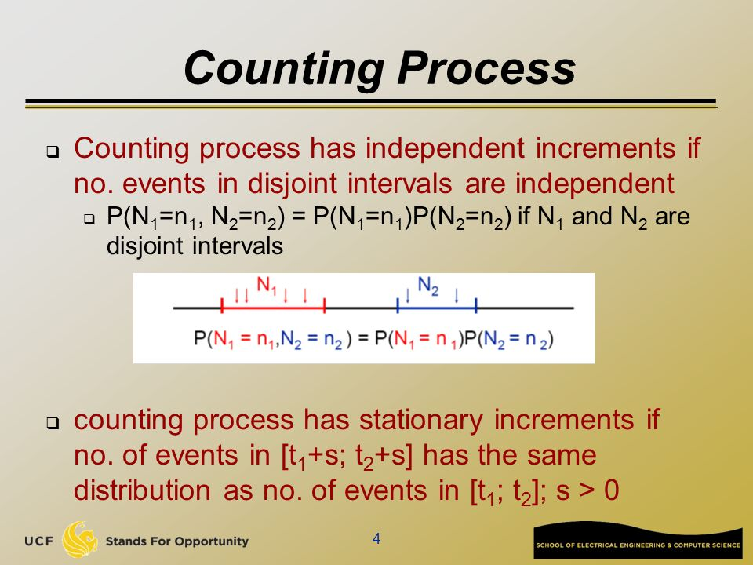

**3)**

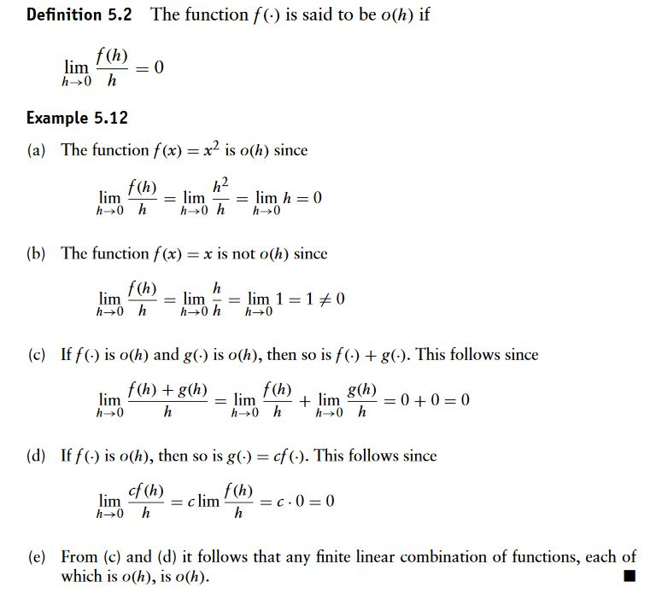

**4)**

|  |  |
| --- | --- |
| **Homogeneous** | **Non-homogeneous** |
| 1) A homogeneous poisson process is characterized by a constant rate parameter [λ](https://en.wiktionary.org/wiki/%CE%BB) | 1) A non-homogeneous poisson process is characterized by a variable rate parameter [λ(t)](https://en.wiktionary.org/wiki/%CE%BB) |
| 2) Constant average rate | 2) variable average rate |
| 3) The number of events in time interval (t, t+ [𝜏) is N(t+ 𝜏) – N(t)](https://www.compart.com/en/unicode/U+1D70F) | 3) The expected number of events between time s and time t is C:\Users\Acer PC\Desktop\Capdd.JPG |
| 4) A homogeneous process is stationary. | 4) The stationary increment property is not satisfied |

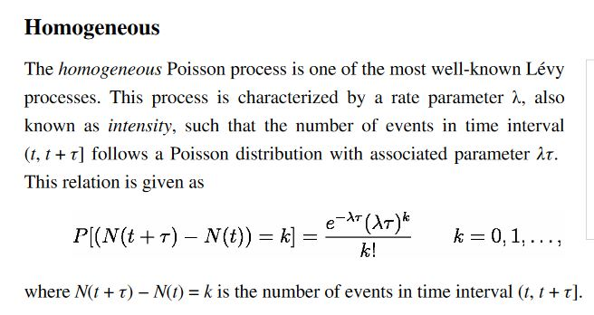

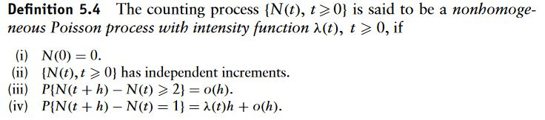

**5)a)**

|  |  |
| --- | --- |
| **Renewal Process** | **Poisson Process** |
| 1) Renewal process is a special kind of arrival process. | 1) Poisson process are a special kind of renewal process. |
| **2)** The inter-arrival intervals are positive, independent and identically distributed (IID) random variables | **2)** In Poisson process inter-arrival times have exponential distribution. |
| **3)** C:\Users\Acer PC\Desktop\aaaaa.JPG | **3)** Poisson process has extra property than Renewal process- Memory-less property.  P(X>t+x | X> t)=P(X>x), x>=0 means it does not depend on past events. |
| 4) A renewal process is stationary. | 4) A poisson process is both stationary and independent. |

**5)b) i) True ii) False iii) False**